
2025/2026
Lab 9: Linear Search and Binary Search

FAKULTI SAINS KOMPUTER DAN MATEMATIK
DATA STRUCTURE & ALGORITHM

VERSION 1
STUDENT INFORMATION

Please fill in your details:
Name: CHONG YU
MATRIC NUMBER:S76136
GROUP:K3
LAB:MP1
DATE:29/12/2025
Table of Contents
INSTRUCTIONS 1
TASK 1: Implementing Linear Search 2
TASK 2: Implementing Binary Search 17

INSTRUCTIONS

Manual makmal ini adalah untuk kegunaan pelajar-pelajar Fakulti Teknologi Kejuruteraan Kelautan dan Informatik, Universiti Malaysia Terengganu (UMT) sahaja. Tidak dibenarkan mencetak dan mengedar manual ini tanpa kebenaran rasmi daripada penulis.
Sila ikuti langkah demi langkah sebagaimana yang dinyatakan di dalam manual.

This laboratory manual is for use by the students of the Faculty of Ocean Engineering Technology and Informatics, Universiti Malaysia Terengganu (UMT) only. It is not permissible to print and distribute this manual without the official authorisation of the author.
Please follow step by step, as described in the manual.

TASK 1: Implementing Linear Search

Objective
In this task, students must be able to:
- Understand the concept of Linear Search
- Implement Linear search.

Estimated Time
[60 Minutes]

definition of Linear Search
Linear Search is defined as a sequential search algorithm that starts at one end and goes through each element of a list until the desired element is found, otherwise the search continues till the end of the data set.
How Does Linear Search Algorithm Work?
In Linear Search Algorithm,
- Every element is considered as a potential match for the key and checked for the same.
- If any element is found equal to the key, the search is successful and the index of that element is returned.
- If no element is found equal to the key, the search yields “No match found”.
For example: Consider the array arr[] = {10, 50, 30, 70, 80, 20, 90, 40} and key = 30
Step 1: Start from the first element (index 0) and compare key with each element (arr[i])
- Comparing key with first element arr[0]. SInce not equal, the iterator moves to the next element as a potential match.
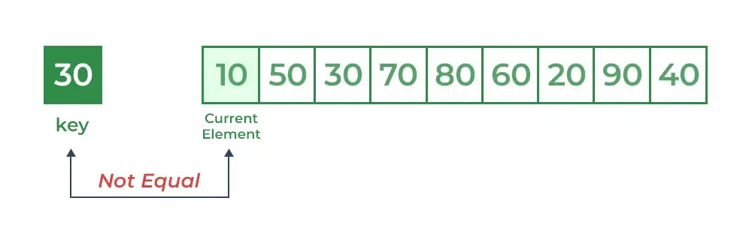
- Comparing key with next element arr[1]. SInce not equal, the iterator moves to the next element as a potential match.

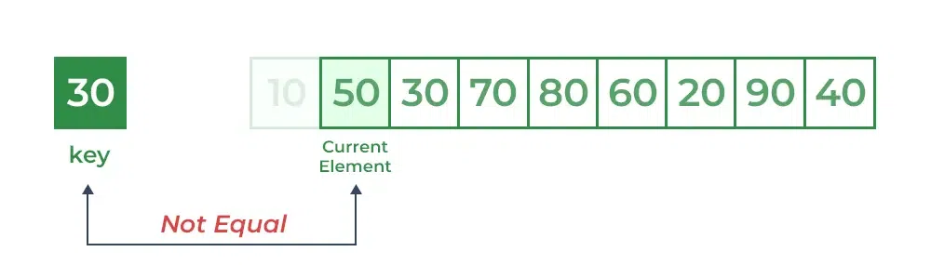

Step 2: Now when comparing arr[2] with key, the value matches. So the Linear Search Algorithm will yield a successful message and return the index of the element when key is found (here 2).
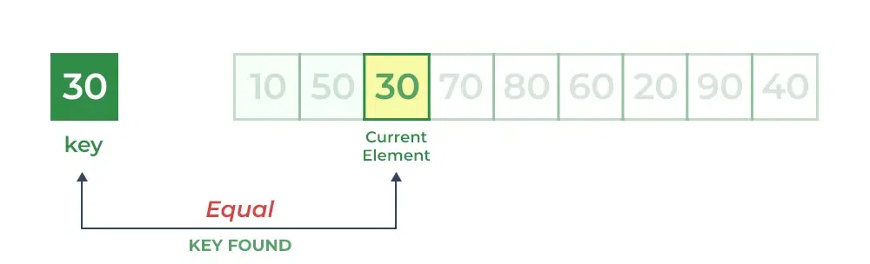

steps:
- After you understand the explanation in the above section, open NetBeans and create a new java application project.
- Name your project as SearchExperiment and click finish.
- Change author profiles to :
  - Name :
  - Program: <put your program. E.g., SMSK(SE) or SMSK with IM
  - Course : CSF3104
  - Lab : <enter lab number>
  - Date : <enter lab date>
- In the same SearchEXperiment project’s package, create a new file named LinearSearch.java.
- Add the following function code to the file:
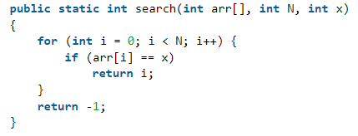
- Test your linear search function in the demo class with the same array the array arr[] = {10, 50, 30, 70, 80, 20, 90, 40} and key = 30

- Save, compile and run your codes. Observe the output.
- Upload your output using the control box below:
- Copy and paste your Java codes into the text box below:
Answer:
package linear.search;

/**
* Name: Chong Yu
* Program: Software Engineering
* Course: CSF3103
* Lab: MP1
* Date: 29 December 2025
*/
public class LinearSearch {
public static int linearSearch(int[] arr, int N, int x) {
for (int i = 0 ; i <= N - 1; i++) {
if (arr[i] == x) {
return i;
}
}

return -1;
}

public static void main(String[] args) {
int[] arr = {10, 50, 30, 70, 80, 20, 90, 4};
int key = 30;

System.out.println("Target index: " + linearSearch(arr, arr.length, key));
}

}

questions
- List the advantages and disadvantages of linear search.
Answer:
More easier to be implement.

- When to use linear search algorithm?
Answer:
When the amount of element are less.

TASK 2: Implementing binary search

objective
During this activity, students will learn and apply the concept of binary search.

estimated time
[60 Minutes]

Introduction
Binary Search is defined as a searching algorithm used in a sorted array by repeatedly dividing the search interval in half. The idea of binary search is to use the information that the array is sorted and reduce the time complexity to O(log N).
Conditions for when to apply Binary Search in a Data Structure:
To apply Binary Search algorithm:
- The data structure must be sorted.
- Access to any element of the data structure takes constant time.

Binary search algorithm
In this algorithm,
- Divide the search space into two halves by finding the middle index “mid”.
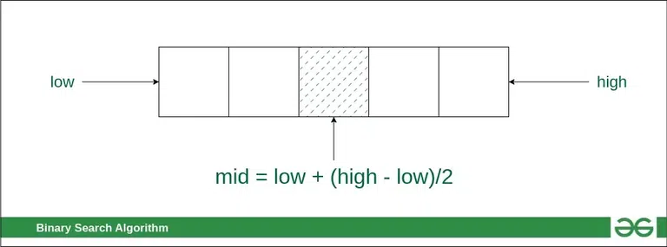

- Compare the middle element of the search space with the key.
- If the key is found at middle element, the process is terminated.
- If the key is not found at middle element, choose which half will be used as the next search space.
  - If the key is smaller than the middle element, then the left side is used for next search.
  - If the key is larger than the middle element, then the right side is used for next search.
- This process is continued until the key is found or the total search space is exhausted.
Consider an array arr[] = {2, 5, 8, 12, 16, 23, 38, 56, 72, 91}, and the target = 23.
First Step: Calculate the mid and compare the mid element with the key. If the key is less than mid element, move to left and if it is greater than the mid then move search space to the right.
- Key (i.e., 23) is greater than current mid element (i.e., 16). The search space moves to the right.
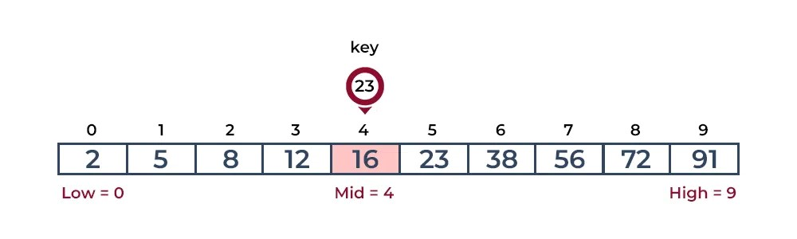
- Key is less than the current mid 56. The search space moves to the left.
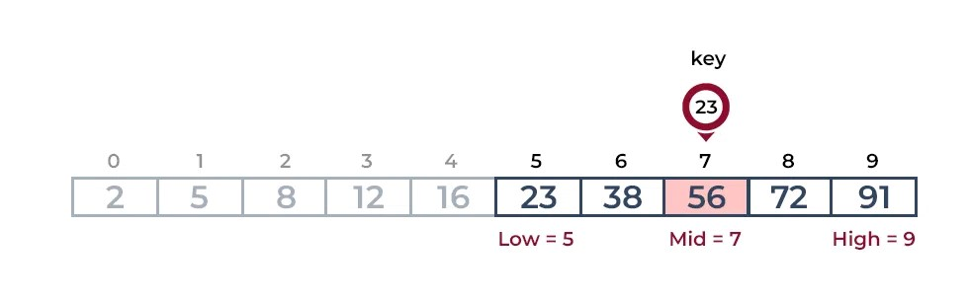
- Second Step: If the key matches the value of the mid element, the element is found and stop search. 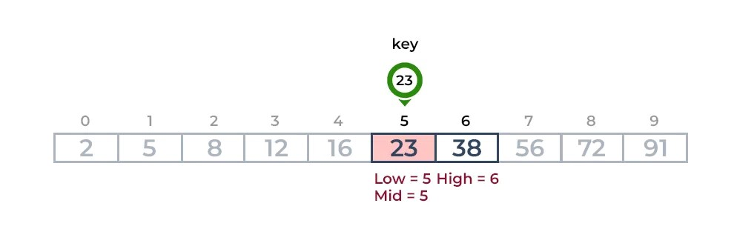
The Binary Search Algorithm can be implemented in the following two ways
- Iterative Binary Search Algorithm
- Recursive Binary Search Algorithm

1. Iterative Binary Search Algorithm:
Here we use a while loop to continue the process of comparing the key and splitting the search space in two halves.

steps:
- Under the same project, Create a new class named BinarySearch.java.
- In BinarySearch.java, insert the following function:
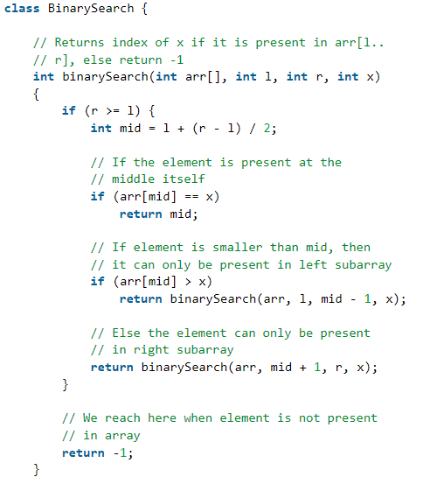

- In the test class, test the above binary search function using the array arr[] = {2, 5, 8, 12, 16, 23, 38, 56, 72, 91}, and the target = 23.
- Save, compile and execute your codes.
- Upload your output using the control box below:

- Copy and paste your Java codes from NetBeans into text box below:
/**
* Name: Chong Yu
* Program: Software Engineering
* Course: CSF3103
* Lab: MP1
* Date: 29 December 2025
*/

int binarySearch(int arr[], int l, int r, int x) {
while (l <= r) {
if (r >= l) {
int mid = l + (r - l) / 2;

if (arr[mid] == x) {
return mid;
}

if (arr[mid] < x)
l = mid + 1;

else
r = mid - 1;
}
}
return -1;
}

/**
*
* @author MP2-4
*/
public class BinarySearchTest {
public static void main(String[] args) {
BinarySearch bs = new BinarySearch();

int[] arr = {2, 5, 8, 12, 16, 23, 38, 56, 72, 91};
int target = 23;

int result = bs.binarySearch(arr, 0, arr.length - 1, target);
System.out.println("Target index: " + result);
}
}

2. recursive Binary Search Algorithm:
Create a recursive function and compare the mid of the search space with the key. And based on the result either return the index where the key is found or call the recursive function for the next search space.

steps:
- In the same class named BinarySearch.java, create a new functionn recursivebinarySearch and insert the following code:
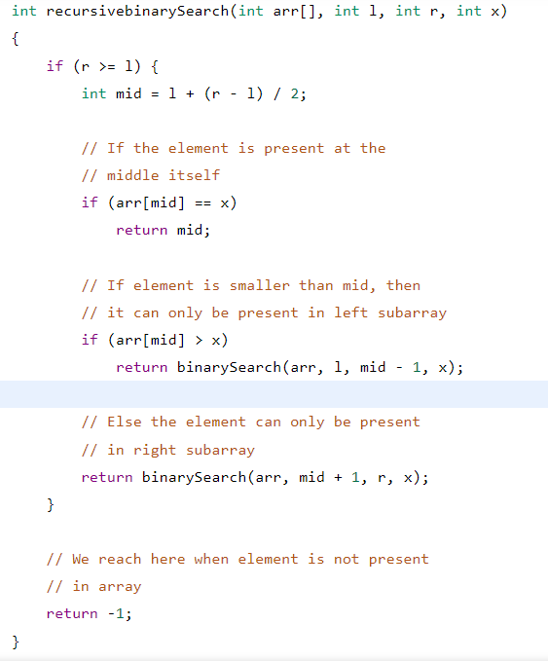

- In the test class, test the above binary search function using the array arr[] = {2, 5, 8, 12, 16, 23, 38, 56, 72, 91}, and the target = 23.
- Save, compile and execute your codes.
- Upload your output using the control box below:
- Copy and paste your Java codes from NetBeans into text box below:
int recursiveBinarySearch(int arr[], int l, int r, int x) {
if (r >= l) {
int mid = 1 + (r - 1) / 2;

if (arr[mid] == x) {
return mid;
}

if (arr[mid] > x)
return binarySearch(arr, l, mid - 1, x);

return binarySearch(arr, mid + 1, r, x);
}

return -1;
}

questions
- List the differences linear and binary search.
Answer:
Linear search searching for item one by one and always starting from the first element. Binary search will start searching from the center of the list and remove the part of list that did not contain target value to speed up searching speed.

- What are the advantages of binary search?
Answer:
Binary seach have shorter time complexity and more faster searching speed.

- Which binary search approach would you prefer to use: recursive or iterative and why ?
Answer:
Iterative. More easier structure compare to recursive approach that can avoid confusion.

Finally, read the instruction regarding submission carefully. Submit your answer using the link provided in Oceania UMT. Please ensure your codes are submitted to the correct group.

